1

# STUDENT ASSESSMENT SUBMISSION AND DECLARATION

When submitting evidence for assessment, each student must sign a declaration confirming that the work is their own.

|  |  |  |
| --- | --- | --- |
| **Student name:abdelkareem yousef mamdoh soubar**  **Student ID:19110022**  **Is the student repeating this unit? NO** | | **Assessor name:** |
| **Issue date:**  19-04-2023 | **Submission date:**  19-06-2024 | **Submitted on:19/6/2023** |
| **Programme:** Computing | | |
| **HTU Course Name:** Network Security **BTEC Course name:** Network Security  **HTU Course Code:** 10203210 **BTEC Course Code:** M/618/7443 | | |
| **Assignment number and title:**  Assignment 1 [JNR Network Security] | | |

**Plagiarism**

**Student declaration**

I certify that the assignment submission is entirely my own work and I fully understand the consequences of plagiarism. I understand that making a false declaration is a form of malpractice.

**Student signature:**

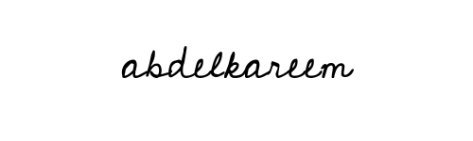

**Date:19/6/2023**

Plagiarism is a particular form of cheating. Plagiarism must be avoided at all costs and students who break the rules, however innocently, may be penalized. It is your responsibility to ensure that you understand correct referencing practices. As a university level student, you are expected to use appropriate references throughout and keep carefully detailed notes of all your sources of materials for material you have used in your work, including any material downloaded from the Internet. Please consult the relevant unit lecturer or your course tutor if you need any further advice.